# **DAY 5 - TESTING, ERROR HANDLING, AND BACKEND INTEGRATION REFINEMENT**

**Overview**  
On Day 5, we focused on making the pharmaceutical Q-commerce system more reliable and efficient. Key tasks included testing how different parts work together, improving input validation, optimizing backend performance, and ensuring the system works well on all devices.

**1. Functionality Testing**  
**Task:** Test key features to ensure they work as intended.  
**Details:**

* Verified the functionality of the medicine filtering (e.g., high-to-low pricing)
* Tested the "Show More" feature to ensure additional products load after clicking, starting with six products displayed by default.
* Products loaded dynamically as expected.  
  **Result:**
* All test cases passed successfully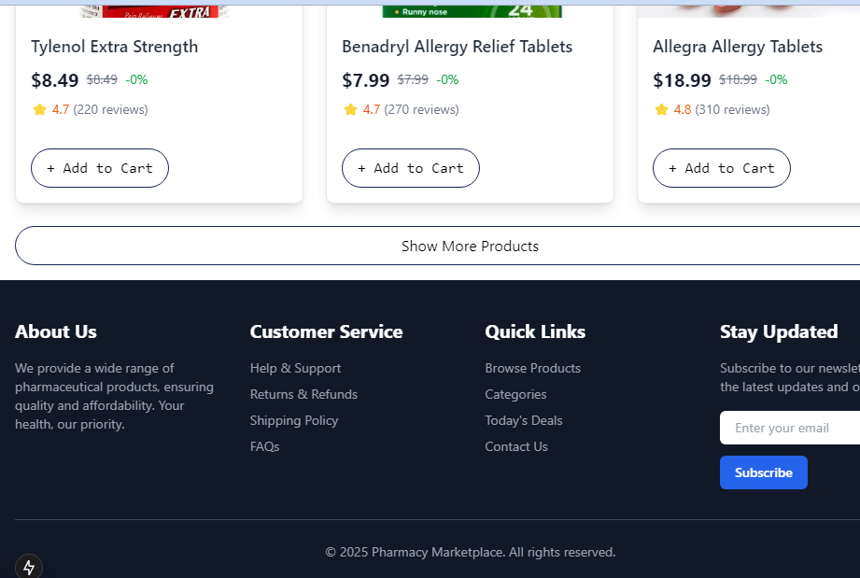.

**Show More** **feature**

* **Products loaded dynamically as expected.**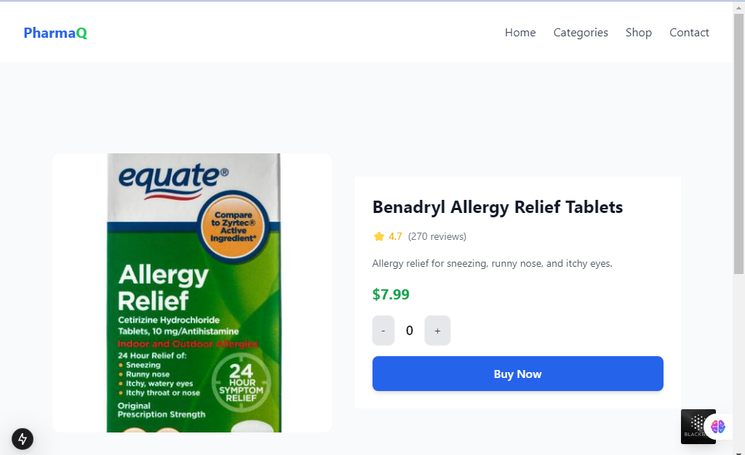

**Medicine filtering (e.g., high-to-low pricing)**

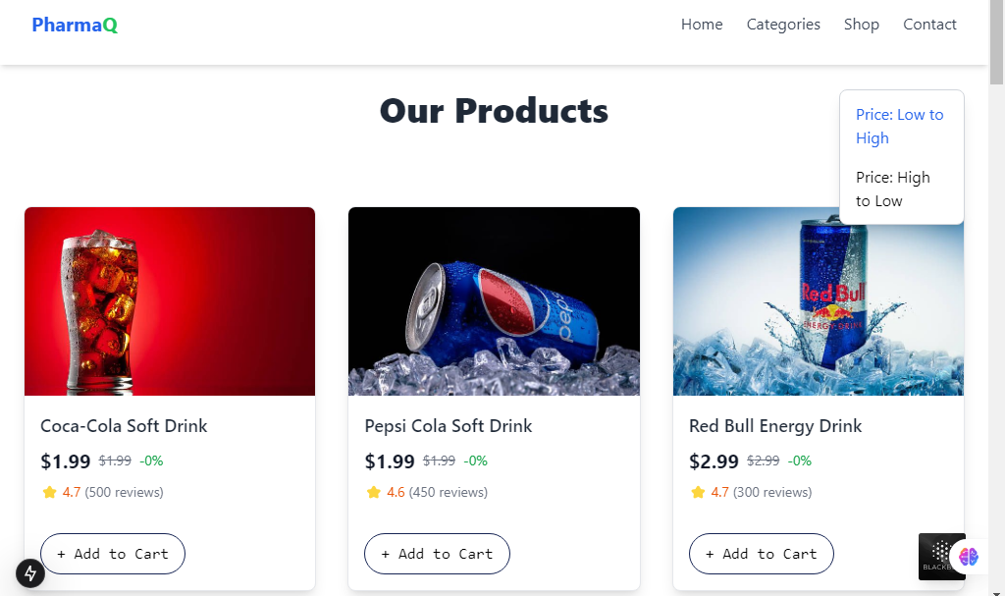

**2. Error Handling**  
**Task:** Implement effective error-handling mechanisms.  
**Details:**

* Simulated scenarios such as internet disconnection and API request failures.
* Verified that clear and user-friendly error messages, like "Error fetching products," are displayed.

**Result:**

* Error messages were successfully shown to inform users of issues, ensuring a better user experience.

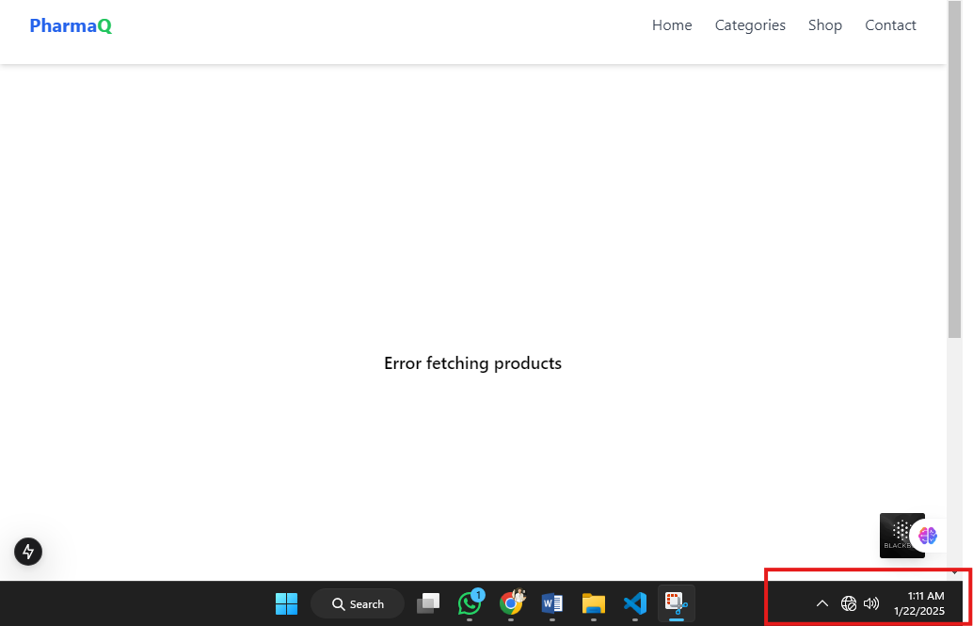

**Cross-Browser and Device Testing**  
**Task:** Ensure the application works smoothly on different browsers and devices.  
**Details:**

* Tested compatibility on Chrome, Brave browsers.
* Verified responsiveness across mobile phones, tablets, and desktop screens.  
  **Result:**
* The application is fully responsive and performs well on all tested browsers and devices.

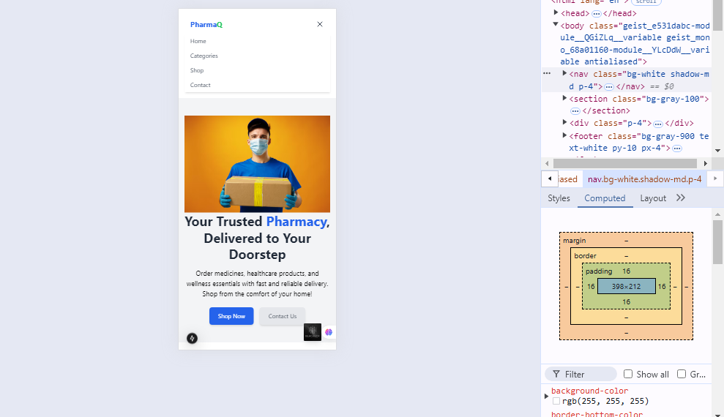

**User Acceptance Testing (UAT)**  
**Task:** Validate the application with real users to ensure it meets expectations.  
**Details:**

* Gathered feedback from friends who tested the platform.
* Identified and resolved minor usability concerns based on their insights.  
  **Result:**
* Testers provided positive feedback, highlighting the platform's functionality, with a few suggestions for small improvements.

**Performance Testing**  
**Task:** Evaluate application speed and responsiveness.  
**Details:**

* Tested product page loading times for both Desktop and Mobile
* Monitored API response times with a performance analysis tool.  
  **Result:**
* Consistent loading times achieved within acceptable thresholds for the pharmacy Q-commerce application. 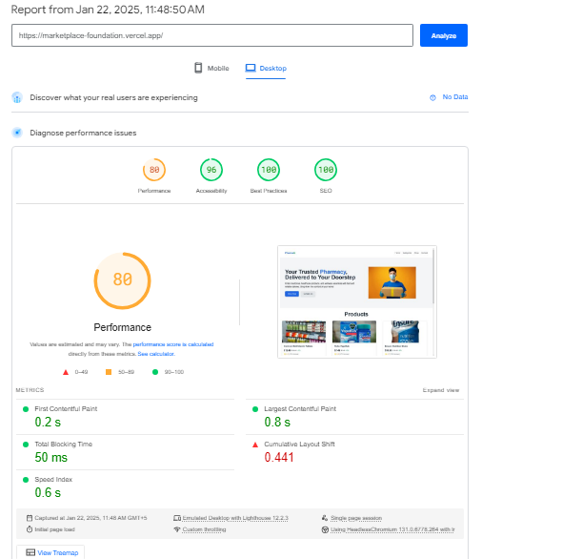

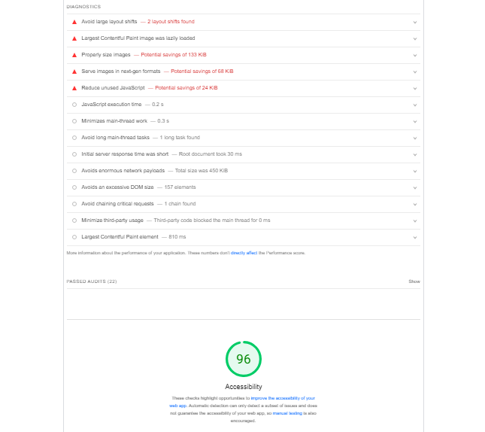

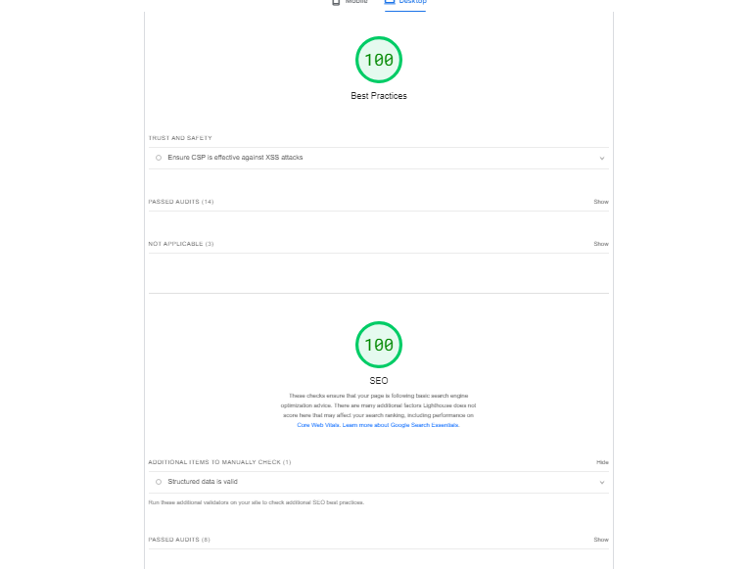

**Conclusion:**  
Today's tasks have greatly enhanced the application's functionality, performance, and reliability. Going forward, the focus will shift to further testing and feature development.